Czech NGO NESEHNUTÍ (http://initiativeway.org/)
invites you to participate in the civil society support program for South Caucasus
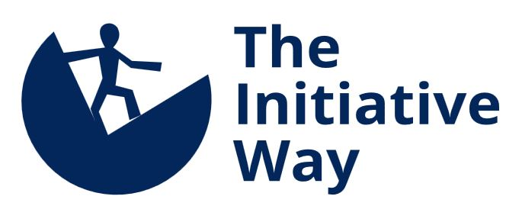
and offers the possibility to obtain support for your civil campaigns and initiatives for the period from June 2014 till December 2015.
Program donor: Ministry of Foreign Affairs of the Czech Republic and International Visegrad Fund
Project partner: organization Abkhazintercont (ფონდი აფხაზინტერკონტი)
Eligible participants:
Eligible participants are NGOs, independent media or informal groups, civil initiatives, local associations and unions from Georgia. Groups which received support from this program in the previous years may also participate. Support shall not be granted to political parties and either formally or informally affiliated organizations (youth, expert etc.)
Priority topics and forms of activities supported in this program:
- Equal opportunities for men and women in society
- Independent and investigative journalism
- Environmental protection
- Right to information
Other topics such as support and protection of human rights (including citizen and social rights), rights of minorities and vulnerable population groups, protection of animals and animal rights can be also supported. Advocacy and watchdog campaigns, as well as civil campaigns engaging the general public shall be given preference. An emphasis will be placed on specific goals, level of participation of citizens and volunteers, and systemic impact of submitted proposals.
What can the selected initiatives look forward to?
- Two- to three-day strategic planning of your campaign (NESEHNUTÍ will provide an expert facilitator, you will ensure participation of your coworkers)
- Training for several selected members of your initiative
- Financial support for your campaign in the average amount of EUR 1,800
- Participation on a short-term study trip (approx. 10 days) to Central Europe (Czech Republic, Slovakia, Poland) for 1 representative of your initiative
- Possibility to participate in the competition for a 3-4 week long internship in the Czech Republic
- Consultations with foreign experts via e-mail and Skype, expert consultations on demand, operational support for your initiative
- Support visits of a foreign expert half-way and at the end of your campaign
How to participate:
Fill in the form below and submit it by March 20th 2014 the latest by e-mail to: tbilisi@nesehnuti.cz. You may also submit your questions to the same email address.
A representative of NESEHNUTÍ will get in touch with the selected initiatives by April 5th 2014 and set a meeting with members of your team during April/May 2014 to discuss the purpose, activities and objectives of your proposal. The decision to support your activities will be made on the basis of this meeting.

The Initiative Way Application Form
Fill in this form briefly and clearly in the maximum length of two A4 format pages.
1. Campaign title:
2. Name of your organization/informal group:
3. Contact person (the person who is responsible for the submitted proposal):
4. Contact details:
- Address:
- E-mail address:
- Phone number:
- Skype:
- Internet site, site or group on Facebook, Twitter, etc.:
5. Country, municipality, district:
6. Previous donors and implemented projects and campaigns:
7. How many people will actively participate in your campaign? (e.g. will participate in the strategic planning and assume responsibility for certain parts of your campaign)
8. What problem does your campaign address?
9. Which specific goals do you wish to achieve?
10. Which social groups will be engaged in your campaign?
11. What type of activities do you plan to implement, and what outcomes do you expect?
12. Who will benefit from the success of your campaign, and how?

